**ESE 562 Project 1**

**Po Hsu Chen, 448031**

1.

Vdd =3V

|  |  |  |  |
| --- | --- | --- | --- |
|  | Gain(db) | Dynamic Range | Power (3*Vdd) |
| 1 na | 90.66 | 2.9999177432 | 9 nw |
| 10 na | 90.3 | 2.9999544002 | 90 nw |
| 100 na | 89.92 | 2.9996431078 | 900 nw |
| 1ua | 88.25 | 2.9965689450 | 9000 nw |

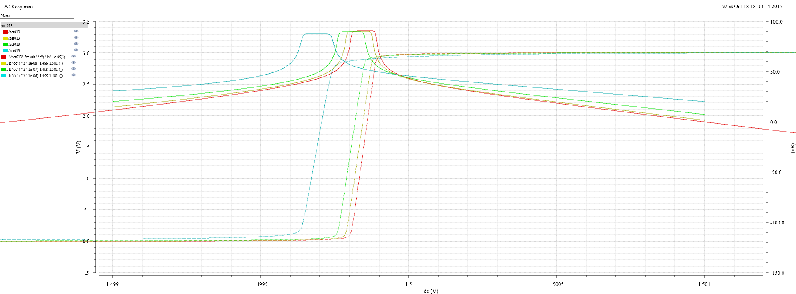

2.

|  |  |  |  |
| --- | --- | --- | --- |
|  | C | Setting Time (sec) | Overshoot |
| 1 ua | 0.1p | 0.000000911 | 59.02800062E-3 |
| 100 na | 0.1 p | 0.000001039 | 17.04848489E-3 |
| 10 na | 0.1 p | 0.000006241 | 270.7085913E-6 |
| 1 na | 0.1 p | 0.000095723 | 335.9898122E-6 |
| 1 ua | 1p | 0.000001317 | 14.39409119E-3 |
| 100 na | 1p | 0.000002788 | 15.94468135E-3 |
| 10 na | 1p | 0.000020056 | 1.948771228E-3 |
| 1 na | 1p | 0.00018319 | 350.935458E-6 |
| 1 ua | 10p | 0.000003481 | 222.5530934E-6 |
| 100 na | 10p | 0.000015944 | 184.690184E-6 |
| 10 na | 10p | 0.00014793 | 668.9398784E-6 |
| 1 na | 10p | 0.001409787 | 416.1767558E-6 |
| 1 ua | 0p | X |  |
| 100 na | 0p | X |  |
| 10 na | 0p | X |  |
| 1 na | 0p | X |  |

Before gain decreases to 0db, phase margin is negative. So the system is unstable and ringing. We can’t measure the setting time due to the above reason.

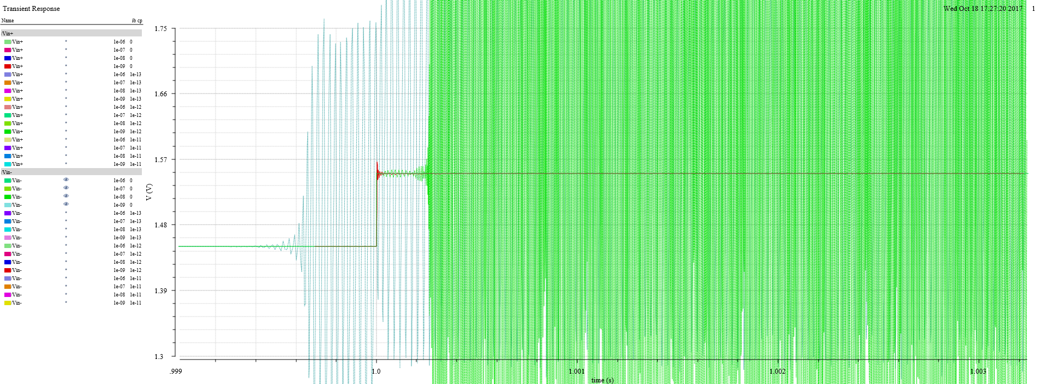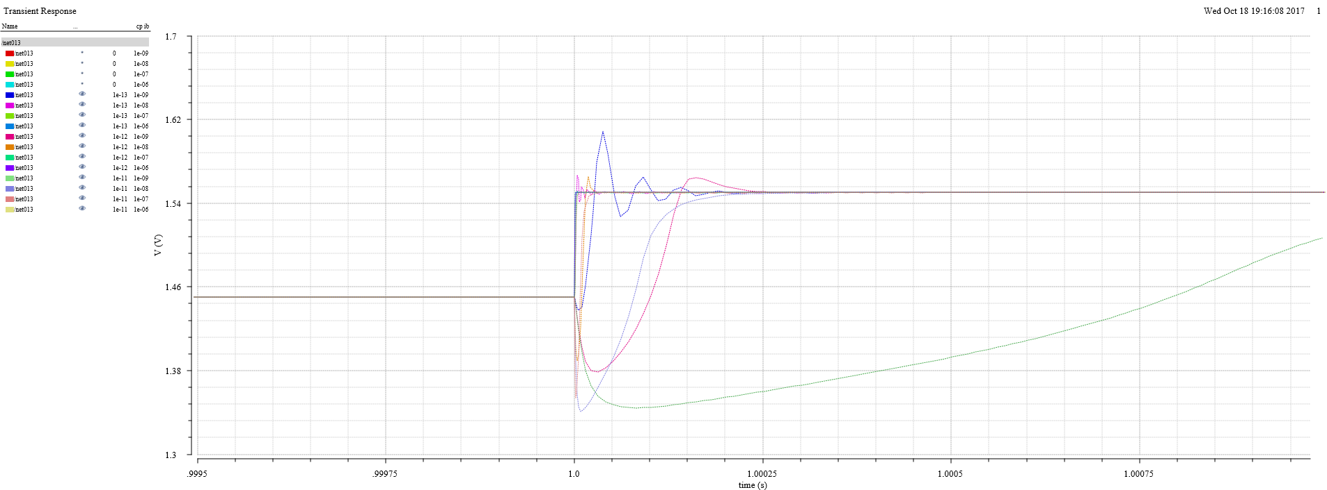

3.

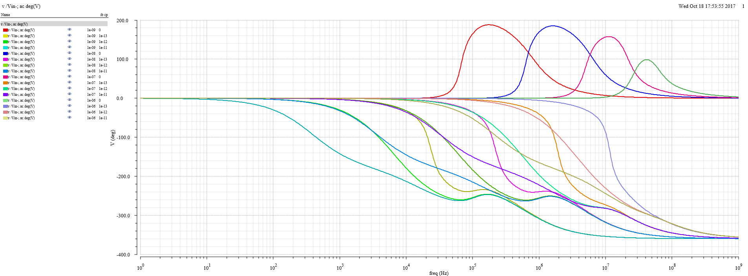

### As the following figure (magnitude plot) shows, there are two zeros and two poles.

**One zero**

**One zero**

**Two pole**

### 

### 20 dB/decade drop of the pole is arrested by the 20 dB/decade rise of the zero resulting in a horizontal magnitude plot for frequencies above the zero location. As a result, the result above perfectly match the circuit. My experiment is successful.